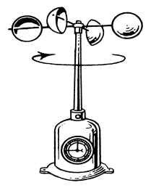  ANEMOMETER  Instrument that  measures wind  speed | 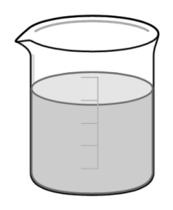  BEAKER  Glass container  with spout for  pouring and marks  for measuring | BUNSEN BURNER  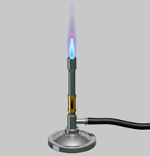  Metal tube for  producing a hot  flame using gas | DOUBLE PAN BALANCE  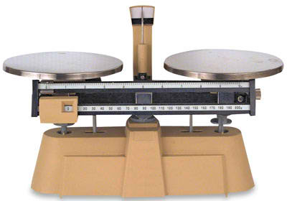  Uses  standard  masses to  measure mass of an object
ERLENMEYER FLASK  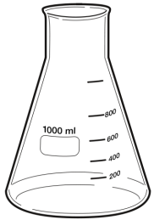  Conical flash with  Narrow neck good  for mixing or  heating liquids | 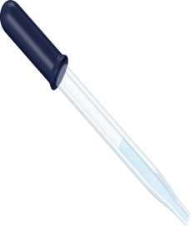  EYE DROPPER  Small tube for  dispensing small  amounts of a liquid | FUNNEL  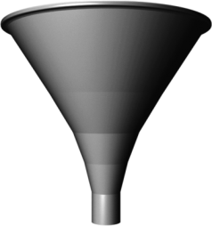  Cone-shaped  object for  pouring liquids  into a small  opening | 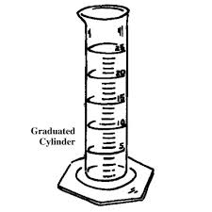  GRADUATED CYLINDER  Container with  markings used for  measuring volume of  liquids
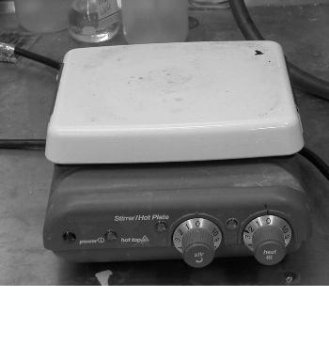  HOT PLATE  Instrument  For heating  Chemicals | METER STICK  Long stick for measuring  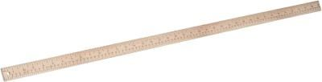  length or distance | 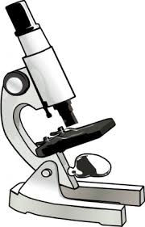  MICROSCOPE  Instrument used  for looking at very  small objects under  magnification | 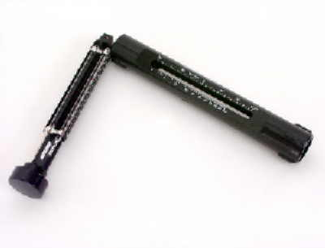  PSYCHROMETER  Instrument for  measuring  humidity (moisture  in the air)
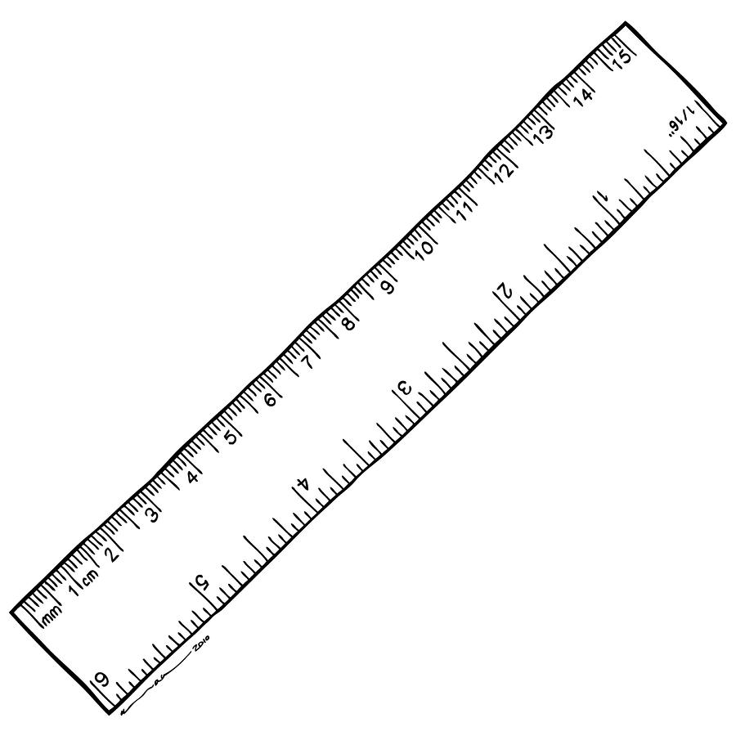  RULER  Instrument  for  measuring  length | 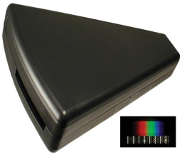  SPECTROSCOPE  Instrument that  splits light into  its component  colors for analysis | 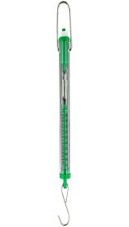  SPRING SCALE  Instrument that  measures force in  Newtons and weight  of objects | 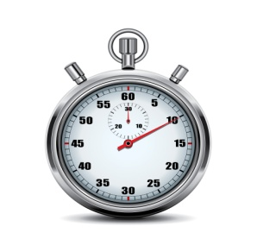  STOPWATCH  Watch that  measures how  long an event  lasts
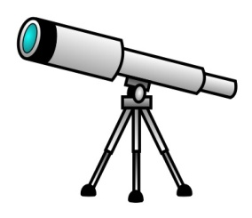  TELESCOPE  An optical  Instrument that  Forms enlarged  Images of distant objects such as stars | 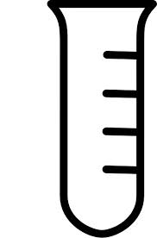  TEST TUBE  Glass tube with one  open end used to  hold chemicals | 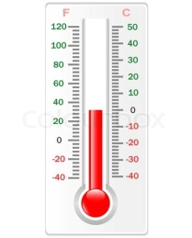  THERMOMETER  Instrument that  measures  temperature  (Celsius or  Fahrenheit | TRIPLE BEAM BALANCE  Scale with 3 weighted beams that  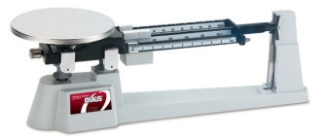  Measures the  Mass of an  object
APRON  A garment used to protect your clothing from chemicals  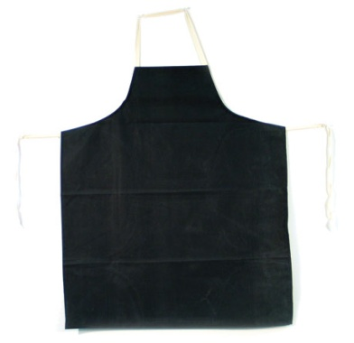 | FIRE BLANKET  A piece of fire-resistant material used to put out fires by throwing the blanket on top of a fire or around a person who has caught on fire  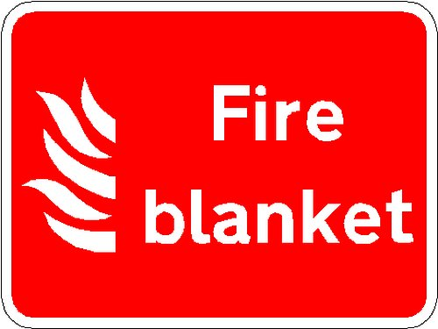 | FIRE EXTINGUISHER  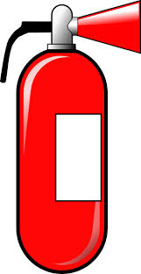  Equipment used for putting out fires by using “PASS”. Pull the pin, aim at the base of the fire, squeeze the handle, and sweep the nozzle back and forth | GOGGLES  Eyeglasses worn in the science lab to protect your eyes from chemical spills, heat, fire, flying objects, and broken glass.  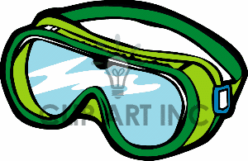
HEAT RESISTANT GLOVES  Gloves used in the science lab to protect your hands from burns  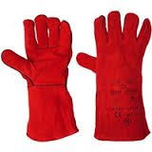 | HEAT RESISTANT MITTS  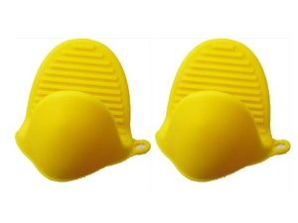  Same as gloves | PIPETTE  A thin tube for dispensing precise amounts of a liquid (like an eye dropper)  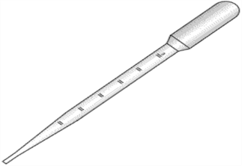 | PETRI DISH  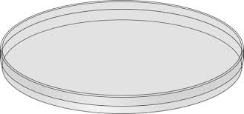  A clear dish with a lid used for growing microorganisms in a nutritious  gel agar

