Descriptive Investigation  - Collecting data that measures or describes objects or events  - It has a question  - No hypothesis or controlled variables | Comparative Investigation  - Observing and collecting data to find similarities and differences between two objects or events  - Includes hypothesis | Experimental Investigation  - Designing a fair test using a procedure with variables & controls to answer a question or problem  - Uses ALL steps of the scientific method
Scientific Method  Organized way to answer a science question/problem with a hypothesis, experiment, variables, multiple trials, data collection, analysis, conclusion | Hypothesis  Educated guess that can be tested to answer a scientific question or problem; an idea that can be tested by experiment or observation | Theory  A well-established, reliable explanation that has been tested in many conditions by multiple people
Independent Variable  Variable that is manipulated during the experiment; it goes on the x-axis  (MIX: Manipulated, Independent, X-axis) | Dependent Variable  Responds to changes in the independent variable and is measured; it goes on y-axis (DRY: Dependent, Responding, Y-axis) | Controlled Variable  Variable that is held constant during an experiment
Metric System  Measurement System that uses metric prefixes to represent powers of 10  (like kilo, hecta, deka, deci, centi, or milli) | Water Displacement  Method used to find the volume of an irregular object by placing the object in water and measuring how much the water volume goes up | Table  Uses columns and rows to organize data
Bar Graph  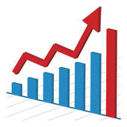  Uses bars to show or compare data in different categories or groups | Circle Graph  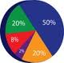  Uses a circle to show parts of a whole (percents) | Line Graph  Shows trends or changes in data, often over time  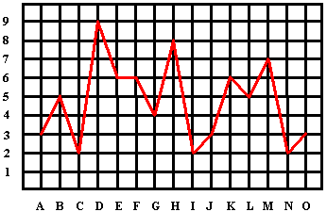
Mean  The arithmetic average; add the numbers and divide by the numbers of numbers | Median  The middle number when arranged in order from least to greatest | Mode  The most frequent number in a list of numbers

